

|  |
| --- |
| **BATCH AND ROLL NO: R6, 42257** |
| **EXPERIMENT NO.1** |
| **TITLE:** Install Android studio. Create Hello World app. |
| **DATE OF PERFORMANCE** |
| **DATE OF CHECKING** |

**Title:** Install Android Studio. Create Hello World app.

# Requirements:

1 Android studio

1. Java SDK

# Theory:

* + Android studio is one of best program for Android app development.
  + It offers a plethora of features and integrated tools for creating a professional Android apps.
  + The program includes a features rich Android emulator, testing tools and consistent development environment. In addition to this it also features an intelligent code editor that provides you with advance code suggestions.
  + Due to many configuration steps, Android Studio may be challenging to set up if you're a novice developer. Here, we show how to install Android Studio on Windows and create a sample application.

# Java JDK

* + Before installing Android Studio, you first need to install the Java JDK and set up the Java environment to start working on it.
  + The Java Development Kit (JDK) is a required development package for creating Java-based applications. Additionally, it also includes tools for developers for testing Java-coded applications.



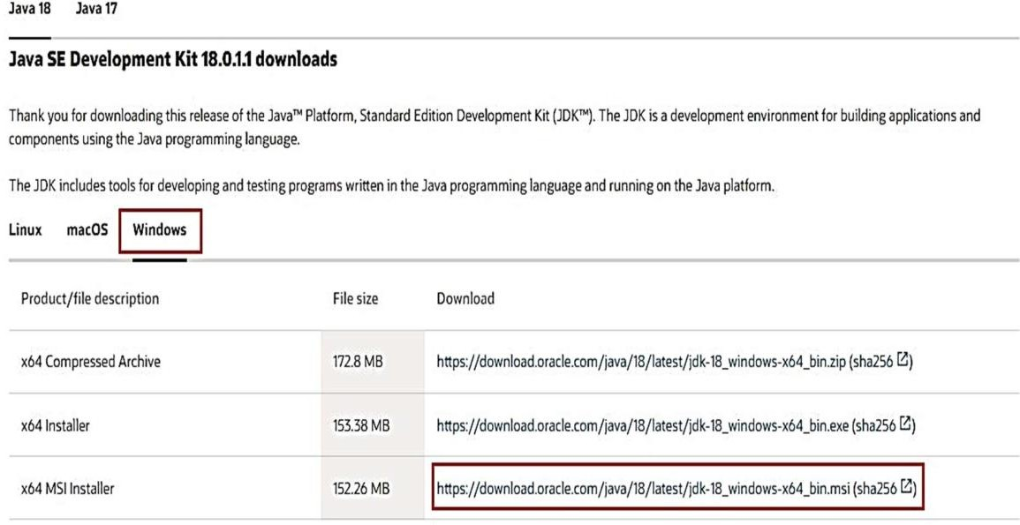

# Follow these steps to get the latest version of Java JDK for Windows and set it up:

1. Go to the official **Oracle Java Downloads** page.
2. Choose the most recent version of Java JDK and download the **x64 MSI Installer** under the **Windows** tab.
3. Open the file you've just downloaded from the **Downloads** folder.
4. Follow the on-screen instructions to install the latest Java JDK.

Once JDK installed successfully, next step is to set up a Java environment so that Android Studio can easily find the location of Java on desktop.



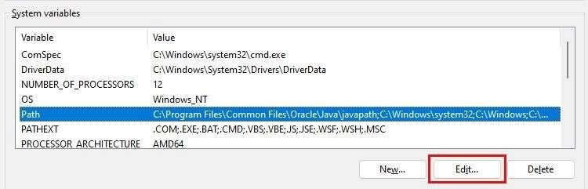

# Steps for Setting Up the Java Environment

1. Open Windows search and type "Edit environment variables."
2. Hit the **Enter** key to open the **Environment Variables** window.
3. Now, under the **System variables** section, click **Path > Edit > New**
4. Copy the path of the folder where the JDK binaries are installed. For example, in our case, the path is **C:\Program Files\Java\jdk-18.0.1.1\bin.**
5. Switch to the Environment variables window and paste the path you've copied and save the changes.
6. Next, under the **User Variables** section, click **New**.
7. Add **PATH_HOME** in the variable name box and **C:\Program Files\Java\jdk-**

**18.0.1.1** in the variable value box.

1. Finally, save the changes by clicking **OK**.

NOTE: [In general, you do not need to reconfigure any environment variables if you have already done so. But if it's your first time, setting the variables will help you reduceJava- based errors during compilation.]



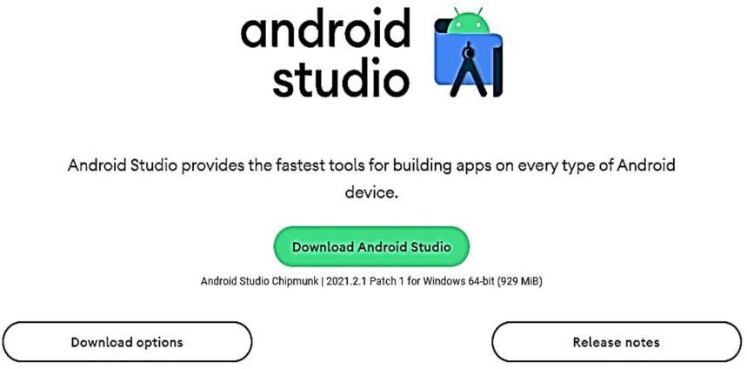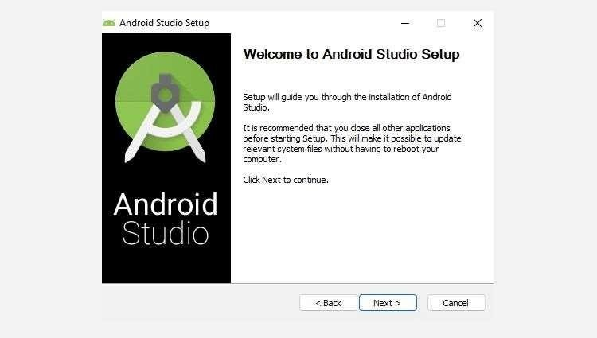

# Steps to Install Android Studio on Windows

1. Visit the **Android Developers** website and click on **Download Android Studio**.
2. Now, open the downloaded file to install Android Studio.
3. Click **Next** to continue installing Android Studio.
4. Further, click **Install** and wait while Android Studio is being installed on your PC.
5. Once done, click **Finish** to close the installer and start Android Studio.
6. Android Studio will now ask you to import settings. Click **OK** to continue to set up Android Studio.



# The System Requirements for Android Studio on Windows

Your PC must meet the following requirements to run Android Studio efficiently:

* + 64-bit Microsoft Windows OS 8/10/11.
  + 1280 x 800 minimum screen resolution.
  + x86_64 CPU architecture; 2nd generation Intel Core or newer; or AMD CPU with Hypervisor support.
  + 8GB of RAM or more.
  + 12GB of available disc space is required (IDE + Android SDK + Android Emulator).

# CONCLUSION:

**……………………………………………………………………………………………**

# ……………………………………………………………………………………………

**……………………………………………………………………………………………**



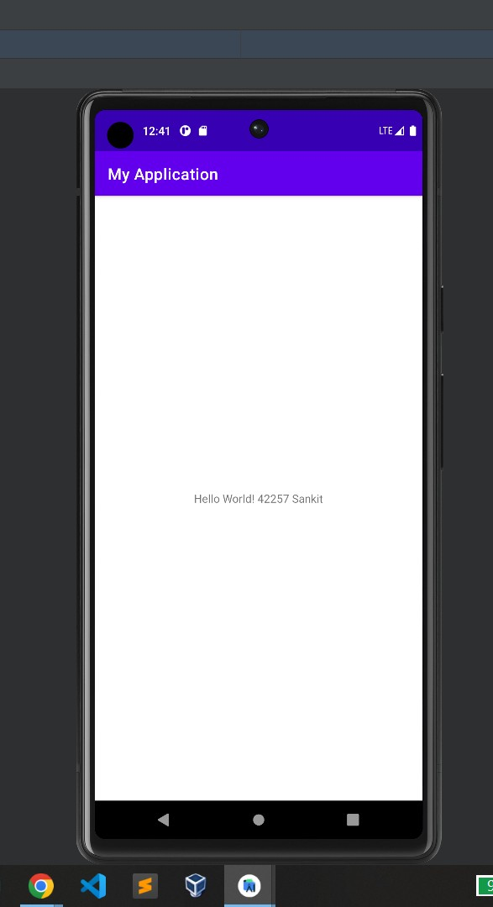

# SAMPLE OUTPUT: